BAV Journal
2016 No. X ISSN 2366-6706
Bundesdeutsche Arbeitsgemeinschaft für Veränderliche Sterne e.V.
http://bav-astro.de

Title of the Publication

First author¹, second author², ….
1) Address, affiliation, e-mail-address
2)
…
month and year of the publication

Abstracts: A brief abstract of the paper should appear here.

The beginning of the publication
A typical paper could be structured into four sections:
Introduction
Observations
Data analysis
Results

At the end of each paper acknowledgements and references will be placed:

Acknowledgements

References

Structure of a reference:
[1] author(s), title, publication
followed by an link or bette using the bib-code
(settings look at http://adsabs.harvard.edu/abs_doc/help_pages/data.html

Typographical regulations
Font: Arial / Size: 11 pt / Standard
Exeptions: Titles: Bold or Underlined / Abstracts: Italic
Section: Single spacing / at the end spacing 6pt.
Please use the full capacity of each page.
Decimal numbers will have a dot, no comma!
Examples

- Figures
For good readability the figures may be as large as possible and reasonable
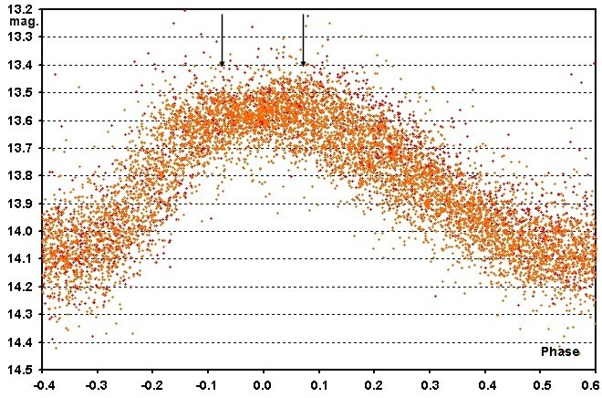
Fig. 1: The peaks of the apparent double max. are marked with arrows

- Tables
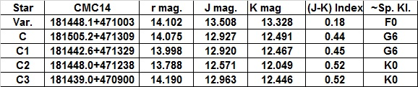
Table 1: The variable, the reference stars and their estimated spectral class

- Formula
To be supplied

